HOW TO START WORK IN GITHUB

- Create a new account
- On main page create a new repository (folder)
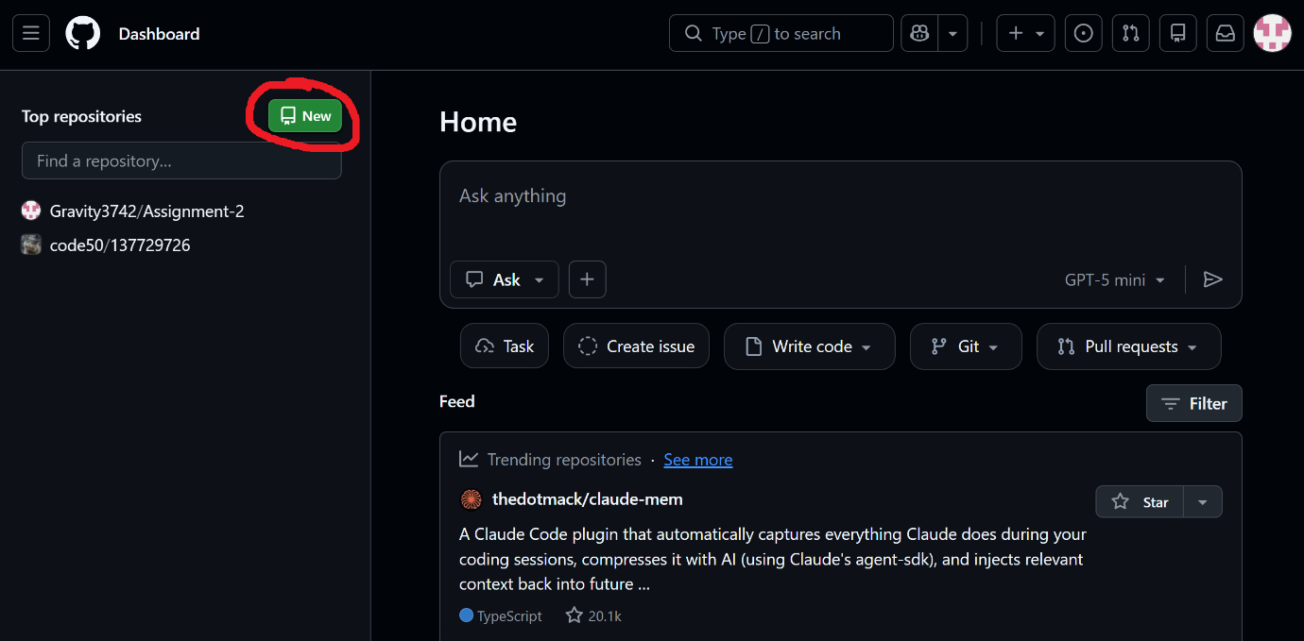
- Give the name to your repository, make it private and create
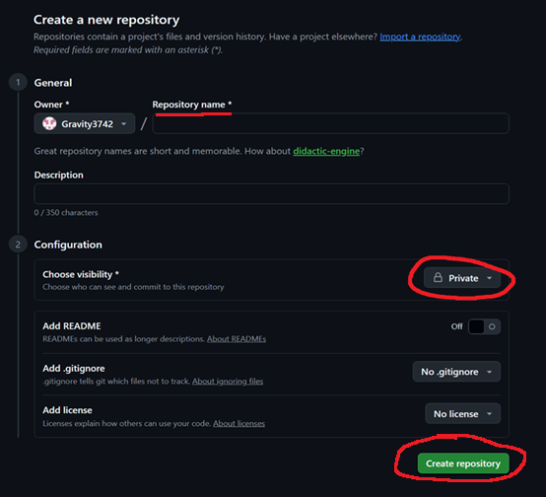

- On the next page, “Create a codespace”
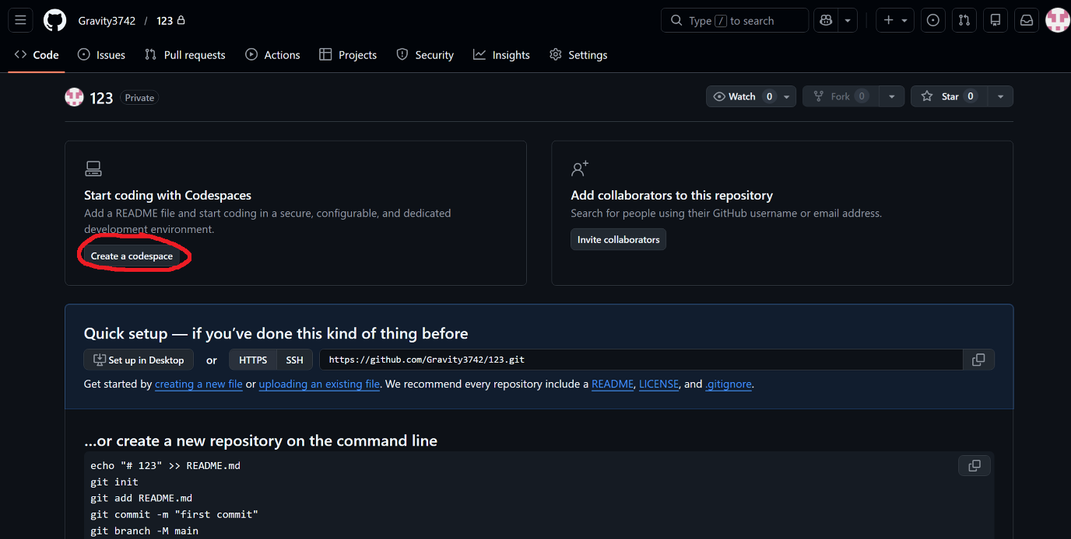
- Use buttons in the top left corner to hide panels and make workspace bigger
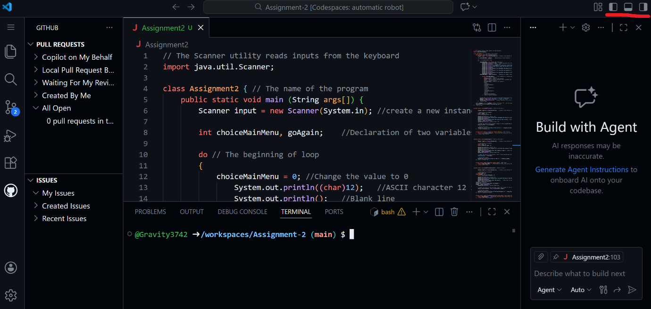

- Now you can forget about casual notepad and work like a pro
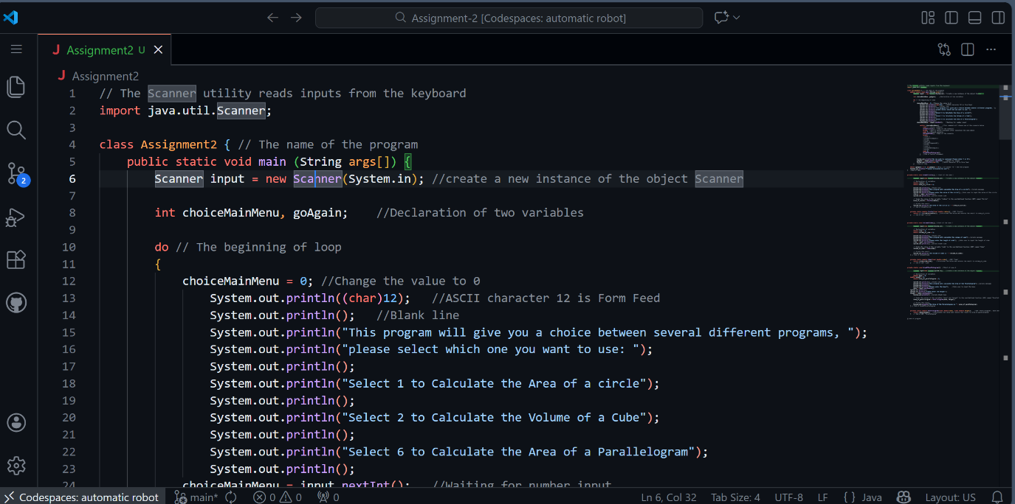

How to get back to codespace:
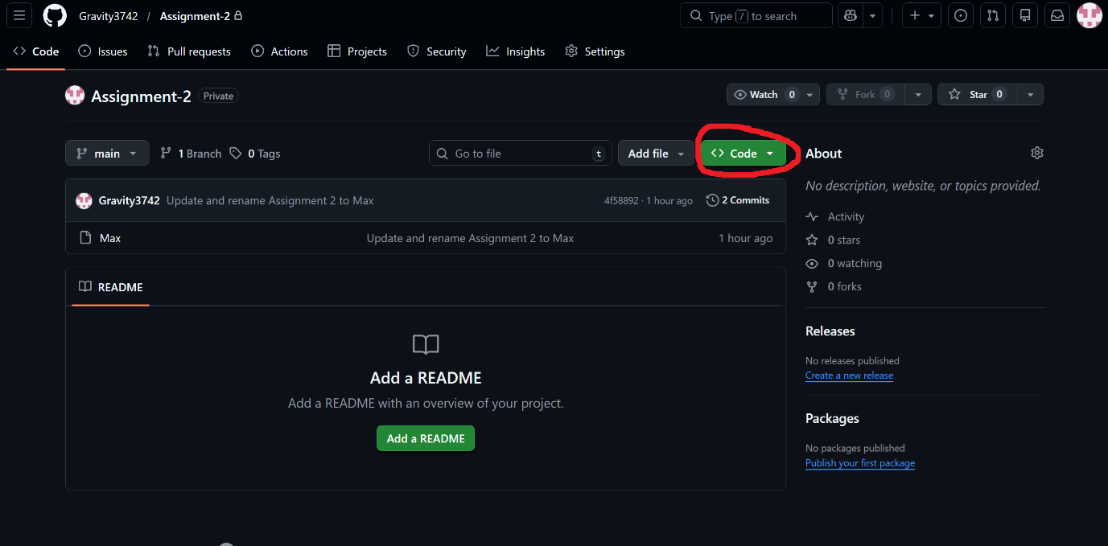

Your workspace will likely be randomly named